# Participant Function

## Black Box Testing

### Register

|  |  |
| --- | --- |
| **Testing Objective** | Register as a member and participant of the system. |
| **Test Input** | Username: rayrokean  Password: 12345  Confirm Password: 12345  First Name: Rayner  Last Name: Paun  Email: ray4308875@gmail.com  Phone Number: 0168047360  Date of Birth: 02/12/1994  Address: Tabuan Jaya, Kuching, Sarawak  Country: Malaysia  State: Sarawak  City: Kuching  Postcode: 93350  Occupation: Student  Newsletter: Yes |
| **Expected Output** | Successfully registered into the database and the system. |
| **Initial Testing Date** | 27th May 2016 |
| **Actual Output** | Successfully registered into the database and the system. |
| **Test Outcome?** | Successful |

### Login

|  |  |
| --- | --- |
| **Testing Objective** | Verify the login of a member and participant of the system. |
| **Test Input** | User Name: rayrokean  Password: 12345 |
| **Expected Output** | Redirects to Participant Home page |
| **Initial Testing Date** | 27th May 2016 |
| **Actual Output** | Redirects to Participant Home page. |
| **Test Outcome?** | Successful |

### Participate

|  |  |
| --- | --- |
| **Testing Objective** | Successfully participated a conference. |
| **Test Input** | Chosen Conference: Autistic Children  Pass Type: VIP  Sponsored? : No  Type of Participation: Chairing a session  Session Name: Raising Autistic Children  Do you require accommodation? : No  Do you want to book a tour? : No |
| **Expected Output** | System displays participation summary, conference schedule and invoice. |
| **Initial Testing Date** | 27th May 2016 |
| **Actual Output** | System displays participation summary, conference schedule and invoice. |
| **Test Outcome?** | Successful |

### Participate with Hotel & Tour Bookings

|  |  |
| --- | --- |
| **Testing Objective** | Successfully participated a conference. |
| **Test Input** | Chosen Conference:  Pass Type: VIP  Sponsored? : No  Type of Participation: Chairing a session  Session Name: Understanding Autistic Children  Do you require accommodation? : Yes   * Preferred Hotel : Riverside Majestic Hotel Kuching * Stay Date From: 06/07/2016 * Stay Date Until: 10/07/2016 * Room Requirement: Non smoking * Number of Adults: 1 * Number of Children: 0 * Special Requirements: NULL   Do you want to book a tour? : Yes   * Tour Name: Bako National Park Day Trip |
| **Expected Output** | System displays participation summary, hotel & tour booking summary, conference schedule and invoice. |
| **Initial Testing Date** | 27th May 2016 |
| **Actual Output** | System displays participation summary, hotel & tour booking summary, conference schedule and invoice. |
| **Test Outcome?** | Successful |

### Hotel Request Booking

|  |  |
| --- | --- |
| **Testing Objective** | Successfully made a hotel request. |
| **Test Input** | Preferred Hotel : Tune Hotel Waterfront Kuching  Stay Date From: 02/07/2016  Stay Date Until: 05/07/2016  Room Requirement: No preferences  Number of Adults: 2  Number of Children: 1  Special Requirements: Extra kid size chair |
| **Expected Output** | System displays request booking summary and invoice. |
| **Initial Testing Date** | 27th May 2016 |
| **Actual Output** | System displays hotel request booking summary and invoice. |
| **Test Outcome?** | Successful |

### Hotel Manual Booking

|  |  |
| --- | --- |
| **Testing Objective** | Successfully booked a hotel manually. |
| **Test Input** | Booked Hotel Name: Pullman Hotel Kuching  Stay Date From: 03/08/2016  Stay Date Until: 05/08/2016  Amount Paid (RM): 267 |
| **Expected Output** | Manual hotel booking summary. |
| **Initial Testing Date** | 27th May 2016 |
| **Actual Output** | Manual hotel booking summary. |
| **Test Outcome?** | Successful |

### Tour Booking

|  |  |
| --- | --- |
| **Testing Objective** | Successfully booked a tour. |
| **Test Input** | Tour Name: Amazing Rafflesia |
| **Expected Output** | System displays tour booking summary and invoice. |
| **Initial Testing Date** | 27th May 2016 |
| **Actual Output** | System displays tour booking summary and invoice. |
| **Test Outcome?** | Successful |

### Cancel Participation

|  |  |
| --- | --- |
| **Testing Objective** | Successfully cancelled a participation. |
| **Test Input** | Conference Reference Number: 109829 |
| **Expected Output** | System displays successful message: Reference Number: --- has been successfully cancelled! The Event Manager will contact you for the disclosure of refund. |
| **Initial Testing Date** | 1st June 2016 |
| **Actual Output** | System displays error message: Reference Number: --- has reached its refundable date! |
| **Test Outcome?** | Fail |

### Provide Feedback

|  |  |
| --- | --- |
| **Testing Objective** | Successfully provided a feedback. |
| **Test Input** | Subject: Good Interface  Comment: The interface is very user friendly and I can navigate the system with ease. |
| **Expected Output** | System displays successful message: Thank you for your feedback! |
| **Initial Testing Date** | 27th May 2016 |
| **Actual Output** | System displays successful message: Thank you for your feedback! |
| **Test Outcome?** | Successful |

### Send Enquiries

|  |  |
| --- | --- |
| **Testing Objective** | Successfully sent an enquiry. |
| **Test Input** | Message Title: Non-member privileges  Message: Hello! May I ask, can a non-member participate a conference? |
| **Expected Output** | System displays successful message: Enquiry sent to the Event Manager! |
| **Initial Testing Date** | 27th May 2016 |
| **Actual Output** | System displays successful message: Enquiry sent to the Event Manager! |
| **Test Outcome?** | Successful |

## White Box Testing

Start

User types in needed data

Email in a correct format?

Confirmed password is same as typed password?

Database

Yes

Yes

No

No

End

Success Message

1

2

33

4

5

Storing the user’s details in the database

Display error message

6

Figure 1: Register

Figure 2: Login

Start

User types Username and Password

Username & Password found?

Redirects to Participant Home page

End

Display error message

Yes

No

1

2

3

4

5

Search database

Database

Start

User enters conference participation details

User chooses a conference

User sets in sponsor name?

Database

Sponsor exists in database?

Displays Participation Summary and Schedule

Displays Participation and Hotel/Tour booking (if there is any) summary

PayPal Payment

Displays invoice

End

Displays error message

Yes

Yes

No

No

User selects to skip hotel/tour booking

Database

Stores user’s participation details into the database

Database

Database extracts the chosen conference’s details into the form

1

2

3

4

5

6

7

8

9

10

11

12

13

Figure 3: Participate

Stores user’s participation and hotel/tour booking details into the database

Start

User enters conference participation details

User chooses a conference

User sets in sponsor name?

Database

Sponsor exists in database?

Displays Participation Summary and Schedule

Hotel / Tour Booking

Displays Participation and Hotel/Tour booking (if there is any) summary

End

Displays error message

Yes

Yes

No

No

Do user require accommodation?

Do user want to book a tour?

Yes

Yes

No

No

PayPal Payment

Displays invoice

Database

Database

Database extracts the chosen conference’s details into the form

1

2

3

4

5

6

7

8

9

10

11

12

13

148

15

Figure 4: Participation with Hotel & Tour Bookings

Start

User fills in request form

Displays Hotel Request Booking Summary

End

Database

Stores user’s hotel booking details into the database

Displays invoice

1

2

3

4

Figure 5: Hotel Request Booking

Start

User fills in booking records form

Displays Hotel Booking summary

End

User books a hotel externally

Database

Stores user’s hotel booking details into the database

Displays invoice

1

2

3

4

5

Figure 6: Hotel Manual Booking

Figure 7: Tour Booking

Start

User selects Tour

Displays Tour Booking summary & invoice

End

Database

Stores user’s tour booking details into the database

1

2

3

Figure 8: Cancel Participation / Booking

Start

Database

Displays list of participation / participation with bookings and Hotel / Tour Standalone bookings

User key in Conference Reference Number / Hotel Booking ID / Hotel Request ID / Tour Booking ID

Displays error message

Participation / Booking validity exceeds 5 days?

Displays successful cancellation message

End

Yes

No

Extracts participation / booking details from the database

Database

Updates the database

1

2

3

4

5

6

7

Figure 9: Provide Feedback

Figure 10: Send Enquiries

Start

User key in Message Title and Message

Displays successful enquiry message

End

1

2

Start

User key in Subject and Comment

Displays successful feedback message

End

1

2

|  |  |
| --- | --- |
| **Cyclomatic Complexity** | v(G) = Edges + Nodes + 2 |

## Figure 1: Register

|  |  |  |
| --- | --- | --- |
| **Path** | **Case** | **Cyclomatic Complexity** |
| 1-2-3 | Incorrect email format | v(G) = 9 - 6+ 2 = 5 |
| 1-2-4-3 | Confirm password is not the same as the password |
| 1-2-4-5-6 | Registration successful |

## Figure 2: Login

|  |  |  |
| --- | --- | --- |
| **Path** | **Case** | **Cyclomatic Complexity** |
| 1-2-3-4 | Incorrect username or password | v(G) = 7 - 5 + 2 = 4 |
| 1-2-3-5 | Login successful |

## Figure 3: Participate

|  |  |  |
| --- | --- | --- |
| **Path** | **Case** | **Cyclomatic Complexity** |
| 1-2-3-4-5-6-7 | Sponsor name is set but does not exists in the database, participation unsuccessful | v(G) = 16 – 13 + 2 = 5 |
| 1-2-3-4-5-6-8-9-10-11-12-13 | Sponsor name is set and exists in the database, participation successful |
| 1-2-3-4-8-9-10-11-12-13 | Sponsor name is not set, participation successful |

## Figure 4: Participate with Hotel & Tour Booking

|  |  |  |
| --- | --- | --- |
| **Path** | **Case** | **Cyclomatic Complexity** |
| 1-2-3-4-5-6-7 | Sponsor name is set but does not exists in the database, participation unsuccessful | v(G) = 21 – 15 + 2 = 8 |
| 1-2-3-4-5-6-8 -9-10-11-12-13-14-15 | Sponsor name is set and exists in the database, participation successful, Hotel & Tour Booking successful |

## Figure 5: Hotel Request Booking

|  |  |  |
| --- | --- | --- |
| **Path** | **Case** | **Cyclomatic Complexity** |
| 1-2-3-4 | Hotel request successful | v(G) = 5 – 4 + 2 = 3 |

## Figure 6: Hotel Manual Booking

|  |  |  |
| --- | --- | --- |
| **Path** | **Case** | **Cyclomatic Complexity** |
| 1-2-3-4-5 | Manual hotel booking successfully recorded | v(G) = 6 – 5 + 2 = 3 |

## Figure7: Tour Booking

|  |  |  |
| --- | --- | --- |
| **Path** | **Case** | **Cyclomatic Complexity** |
| 1-2-3 | Tour booking successful | v(G) = 4 – 3 + 2 = 3 |

## Figure 8: Cancel Participation / Booking

|  |  |  |
| --- | --- | --- |
| **Path** | **Case** | **Cyclomatic Complexity** |
| 1-2-3-4-5 | Participation / Booking validity exceeds 5 days, cancellation unsuccessful | v(G) = 9 -7 + 2 = 4 |
| 1-2-3-4-6-7 | Participation / Booking cancelled successfully before 5 days validity expires |

## Figure 9: Provide Feedback

|  |  |  |
| --- | --- | --- |
| **Path** | **Case** | **Cyclomatic Complexity** |
| 1-2 | Provide feedback successful | v(G) = 3 - 2 + 2 = 3 |

## Figure 10: Send Enquiries

|  |  |  |
| --- | --- | --- |
| **Path** | **Case** | **Cyclomatic Complexity** |
| 1-2 | Send enquiries successful | v(G) = 3 – 2 + 2 = 3 |

# Coding for Validations

### Register.php

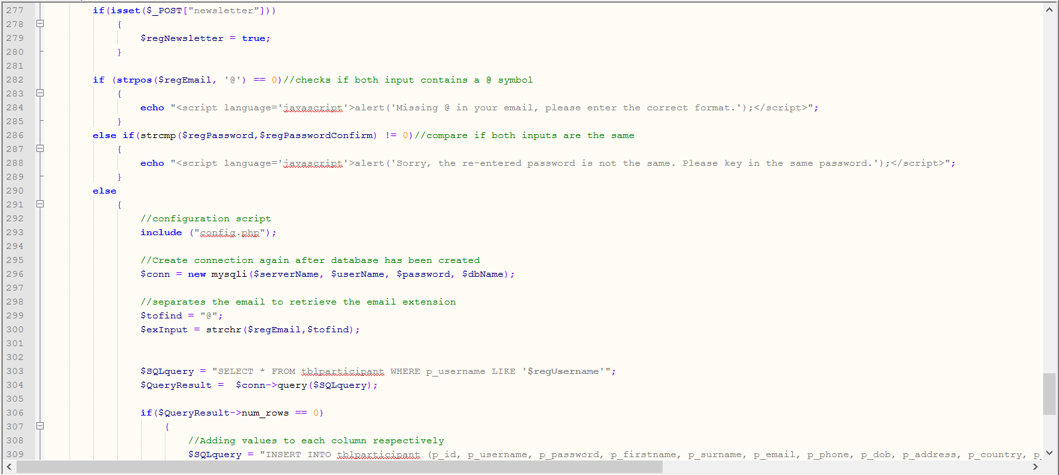

Figure 11: Validating email and re-typed password

### Login.php

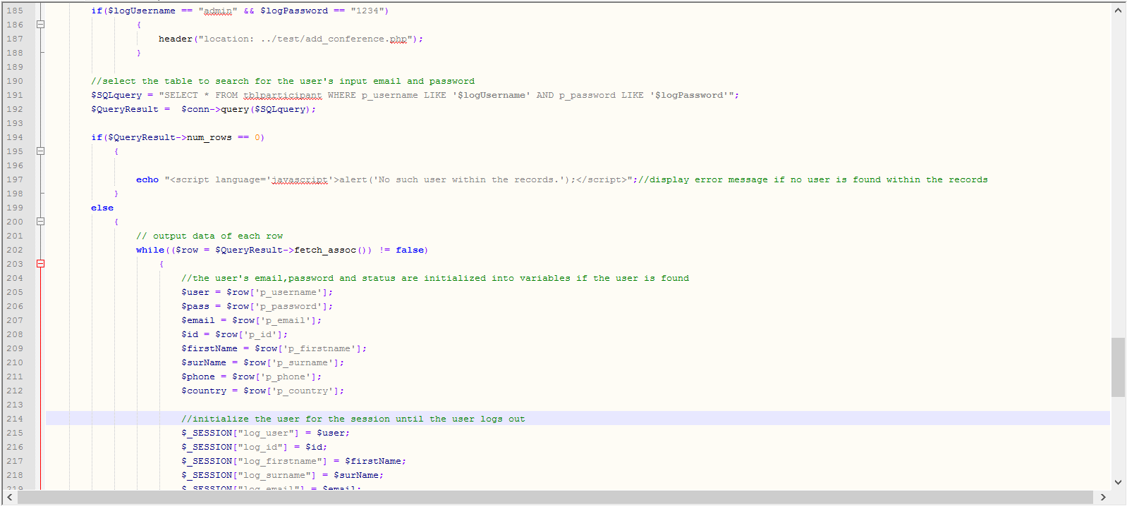

Figure 12: Validating if there's such registered user within the database

### processParticipate.php

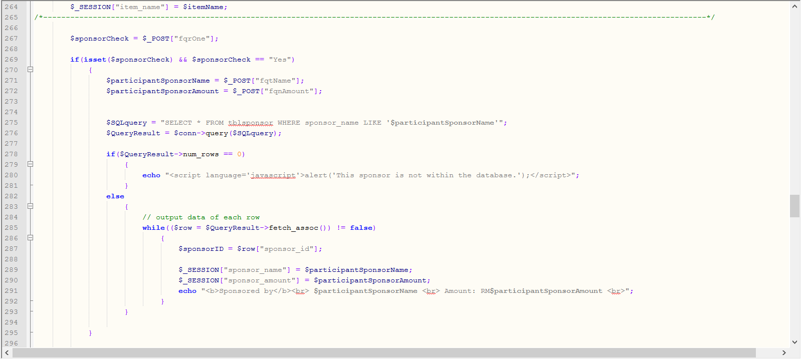

Figure 13: Validating whether there's such sponsor within the database

### cancelParticipation.php

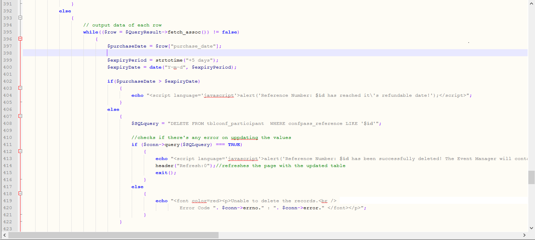

Figure 14: Validating whether the expiry date of participation cancellation has passed

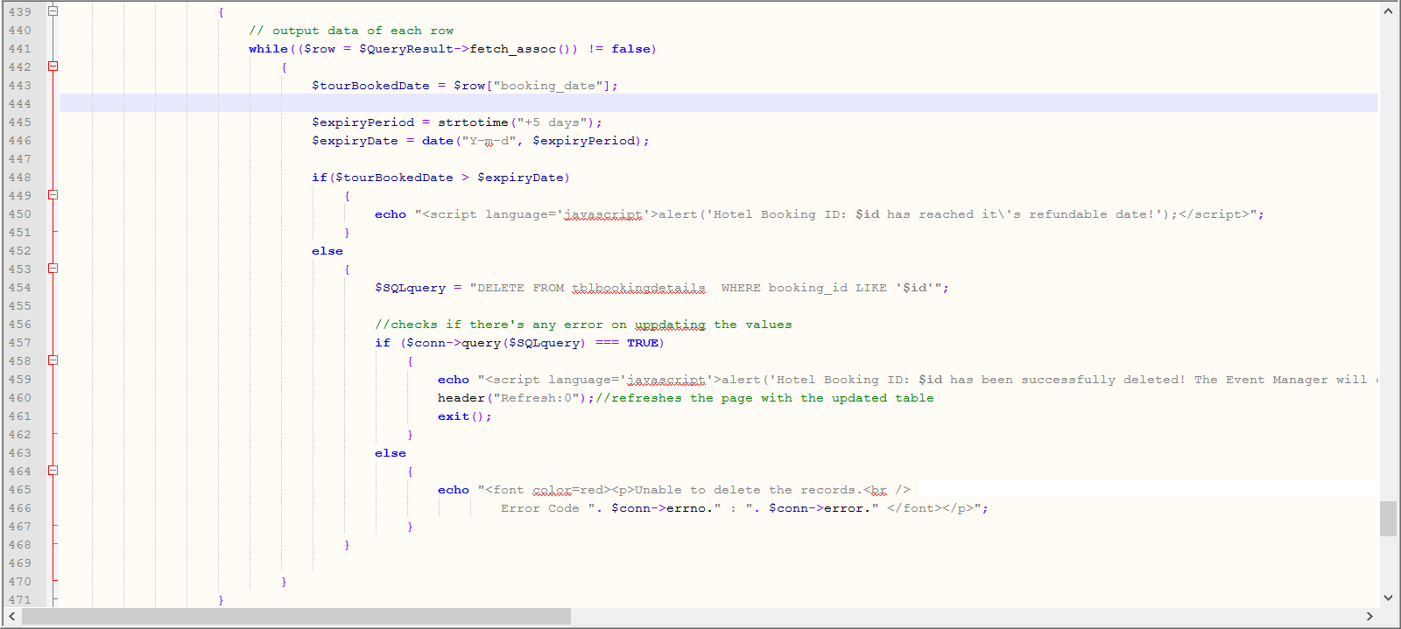

Figure 15: Validating whether the expiry date of hotel booking cancellation has passed

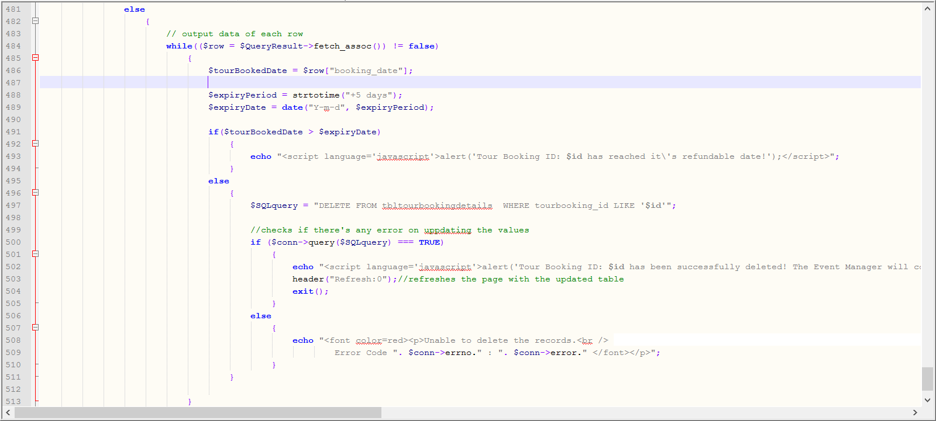

Figure 16: Validating whether the expiry date of tour booking cancellation has passed